**Convulution Neural Network**

Mengting Ding

Cifar 10 dataset from keras is used to build the deep neural network. In the preprocessing section, since there are ten different types of pictures in the dataset, therefore, y variables are encoded using one-hot encoding and changed x_test and x_train into floating point type.

In the model building section, in the final Dense layer softmax is used as activation since this is a multiclassification problem, and the output dimesion should be set as 10. Rescaled the picture dividing by 255.

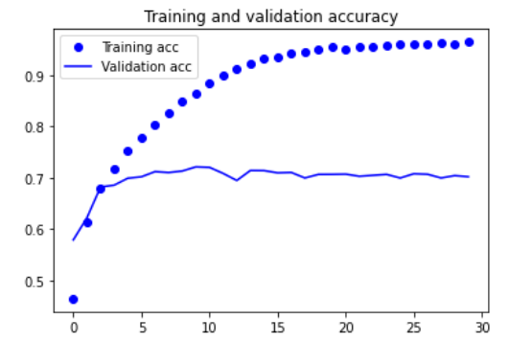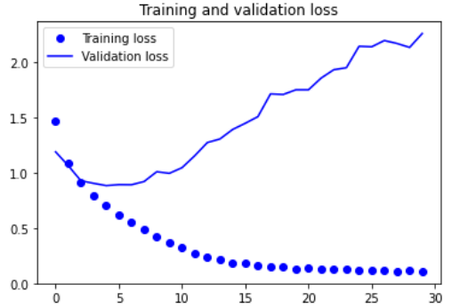

Training accuracy: 0.96, validation accuracy: 0.7

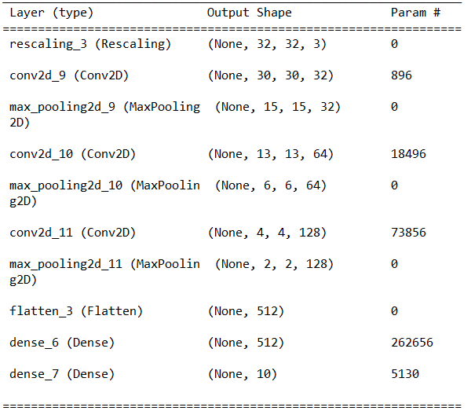

Traning accuracy is much higher than validation accuracy, this could mean that the neural network is overfitting the training dataset.

**Experiment with preprocessing the input data**

1. Data augmentation
2. Plot charts

In this part data augmentation is applied before setting up the model.

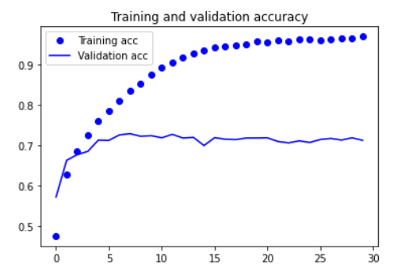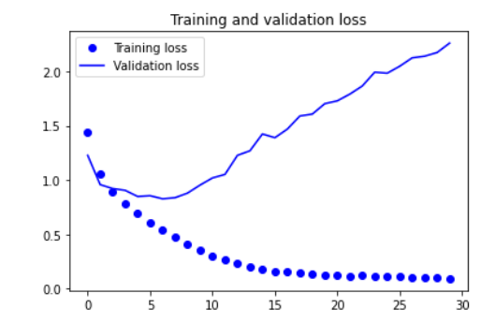

Training accuracy: 0.95 Validation accuracy: 0.7

From the two plots and training and validation results, it is clear that there is no significant improvement of performance than in question 2.

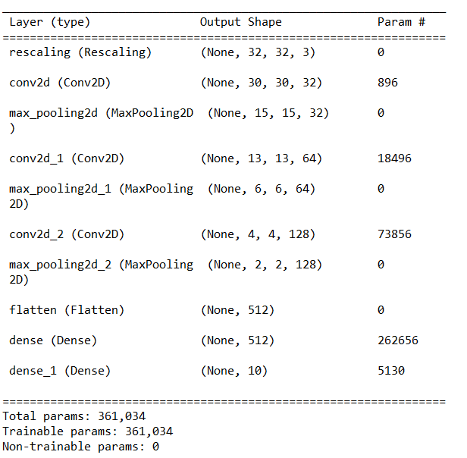

**Network structure (3 rd NN)**

Create a NN only has one hidden Convolutional layer

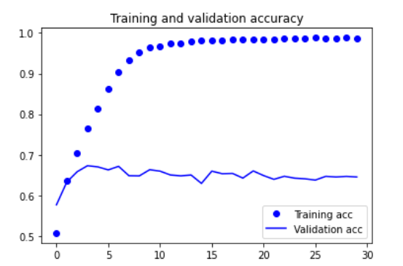 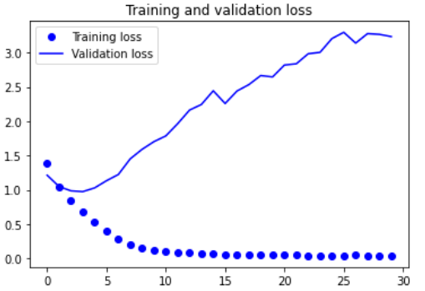

Validation accuracy: 0.645 training accuracy: 0..9867

Compared with the Neural Network with three hidden convolutional layers, the validation accuracy dropped slightly for the CNN has only one hidden convolutional layer.

**4th NN one more layer than NN in Q2**

1. Plots

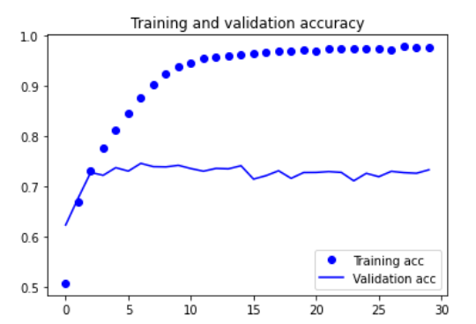 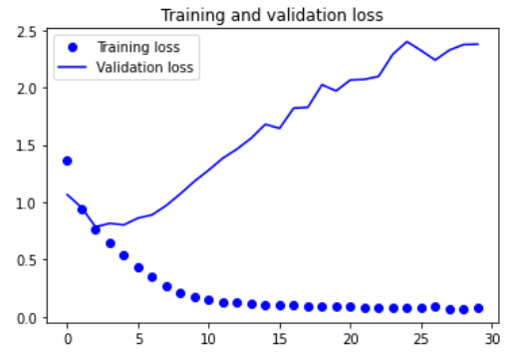

Training accuracy: 0.976 Validation accuracy: 0.73

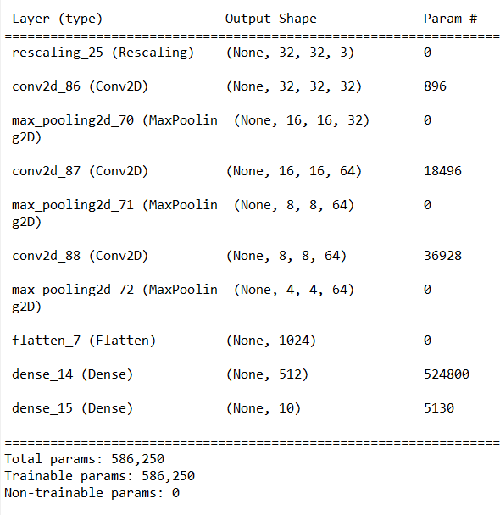

Adding one more layer performs better than before, validation accuracy has increased slightly from 0.7 (Q2) to 0.73.

**Add Dropout in part 2 create the 5th NN**

1. Plots

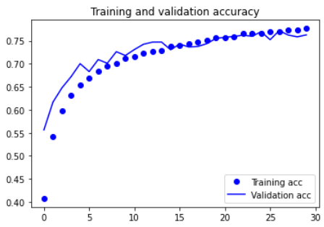 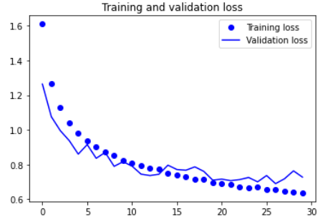

Training accuracy: 0.77 Validation accuracy: 0.76

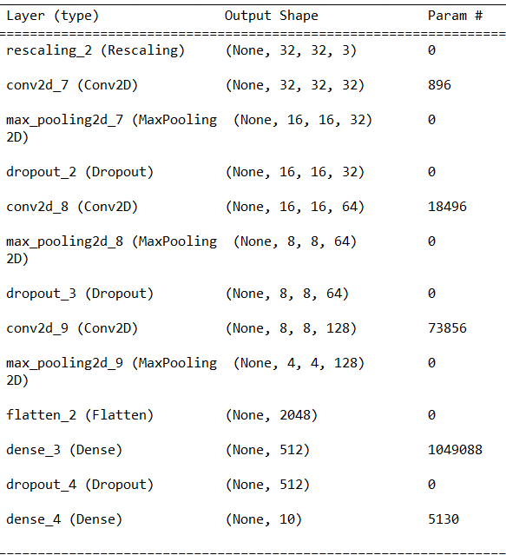

1. Comments

After adding dropout for each convolution layer, with dropout rate the training accuracy is close to the testing accuracy and the loss are very close as well, indicating that this neural network is not overfitting in the training dataset.

Comparing the output of each neural network, the neural network with dropout is the best CNN among all.